ACADEMIA INTERNACIONAL DAVID

TECHNOLOGY AND ROBOTICS 8TH
QUIZ #1
I TRIMESTER

NAME: ________________________________ DATE: ______________________
TEACHER: PORFIRIO RIOS. LEVEL: 8 A B
This is an individual test. Read your test carefully before answering. Use blue or black ink. Overwriting, crossing out, double answers or using correction pen are not allowed, if so, answers will be considered incorrect. Develop this test silently. If you have questions, raise your hand.
Name and date. 2 pts.  Complete name and date in the correct English Format. |  | Spelling 2 pts.  ½ point less each spelling or capitalization mistake.
Follow instructions. 1 pt.
Content: 45 points. |  | Total Points: 50 points.

Part A: Multiple Choice - 10 pts
Read each question carefully. Choose the one best answer and circle or mark only one option: a, b, c, or d. If you choose more than one answer, the question will be counted as incorrect.
1. What is hardware?
a) Programs and apps
b) The physical parts of a computer
c) The internet
d) A document
2. What is software?
a) The parts of a computer you can touch
b) Programs that tell hardware what to do
c) A type of keyboard
d) A monitor
3. Which of the following is an example of hardware?
a) Windows
b) Browser
c) Keyboard
d) App
4. Which of the following is an example of software?
a) Mouse
b) SSD
c) Printer
d) Operating system

Part B: Matching - 10 pts
Match each term on the left with the correct function on the right. Write the correct letter on each blank line. Use each letter only once.
Terms  A. Processor (CPU)  B. Memory (RAM)  C. Storage  D. Input device  E. Output device | Functions  _____ 1. Keeps files and programs saved for later  _____ 2. Helps the computer think and process instructions  _____ 3. Lets the user enter data into the computer  _____ 4. Shows or delivers information from the computer  _____ 5. Holds information temporarily while the computer is working

Part C: True or False - 5 pts
Read each statement carefully. Write True if the statement is correct. Write False if the statement is incorrect. Write your answer clearly on the line.
_____ 1. Hardware means the programs installed on a computer.
_____ 2. Software tells the hardware what to do.
_____ 3. A keyboard is an output device.
_____ 4. RAM is a type of memory.
_____ 5. Storage keeps files saved even after the computer is turned off.
Part D: Complete the Truth tables - 8
Complete each truth table by writing the correct output value (Y) for every row. Look at the input values A and B, then decide if the output should be 0 or 1 for the AND gate and the OR gate.

AND
A | B | Y
0 | 0
1 | 0
0 | 1
1 | 1

OR
A | B | Y
0 | 0
1 | 0
0 | 1
1 | 1

PART E: Complete the Circuit and Write the Correct Output - 4 pts.
Look at each circuit carefully. Complete the missing part of the circuit, then decide what the final output should be. Write the correct output value in the box. Use what you know about logic gates and input values.

CIRCUIT 1 – 2 PTS

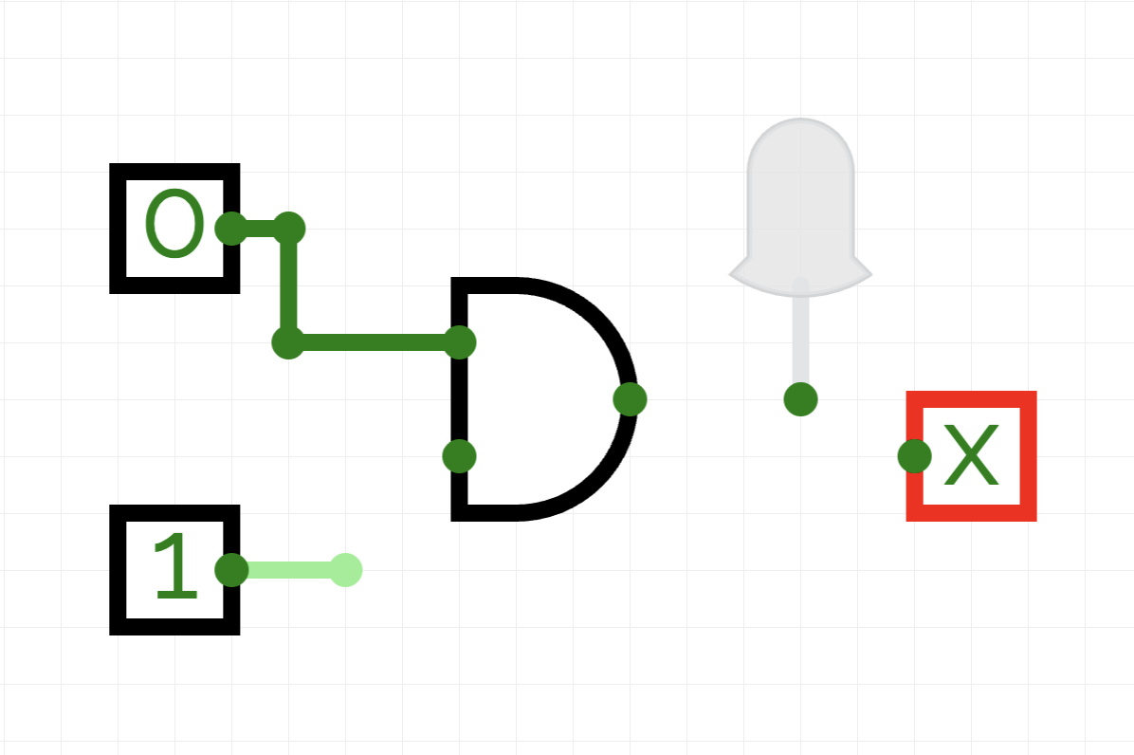

CIRCUIT 2 – 2 PTS
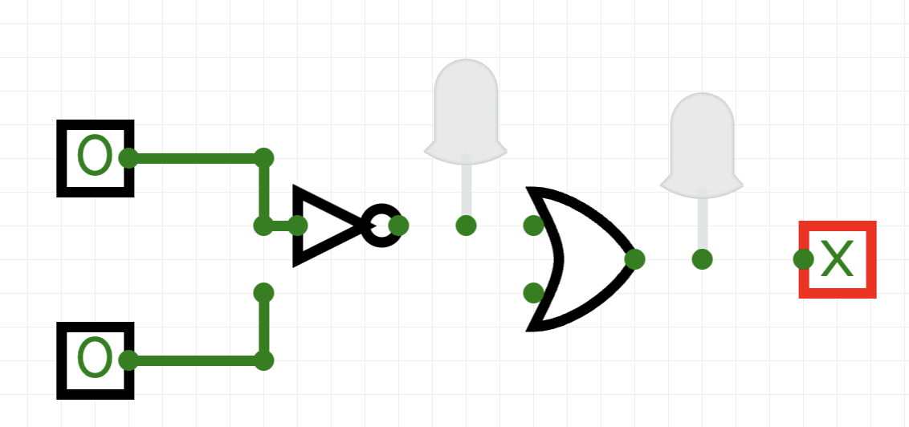

PART F: Name the gates in the following circuit - 8pts
Look at the circuit diagram carefully and identify each logic gate shown. Write the correct name of each gate in the space provided. Use the gate shapes to help you decide.

